EXPERIMENT -1

ROLL NO:240701495 NAME: SHERIN KATHERINA D

USER INTERFACE AND DESIGN
COMAPARSION OF UI DESIGN BETWEEN TWO FIGMA CREATION
BAD WEBSITE:
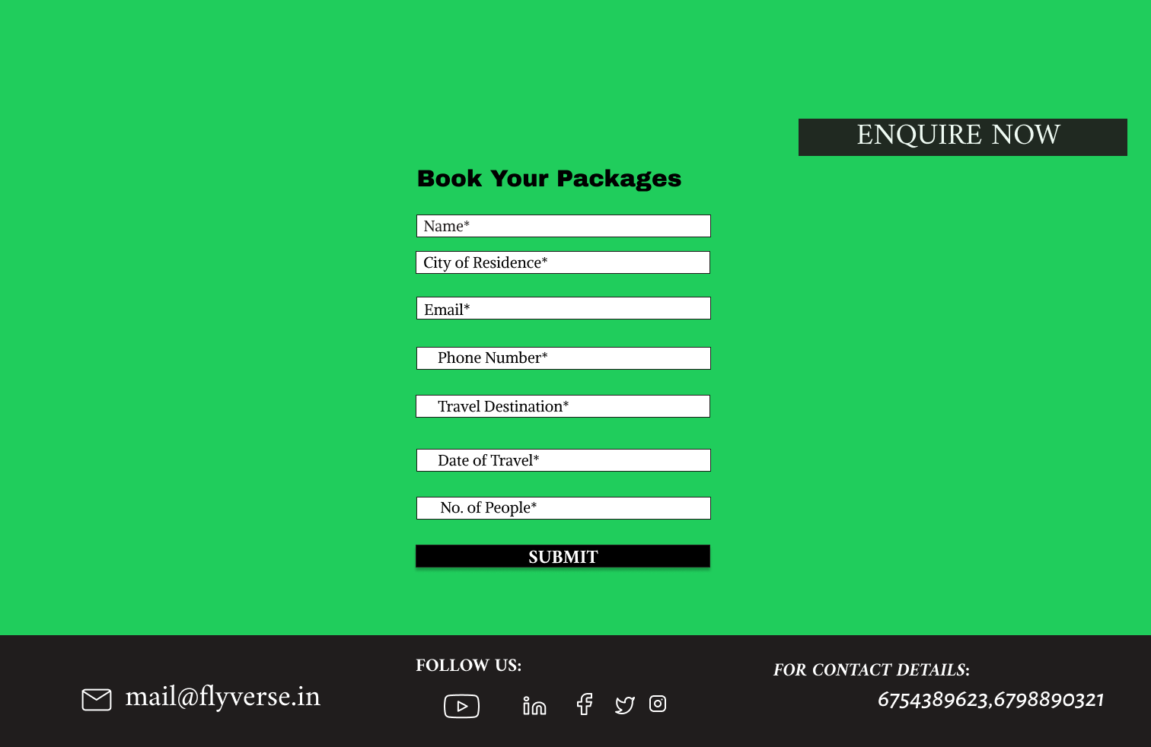

GOOD WEBSITE:
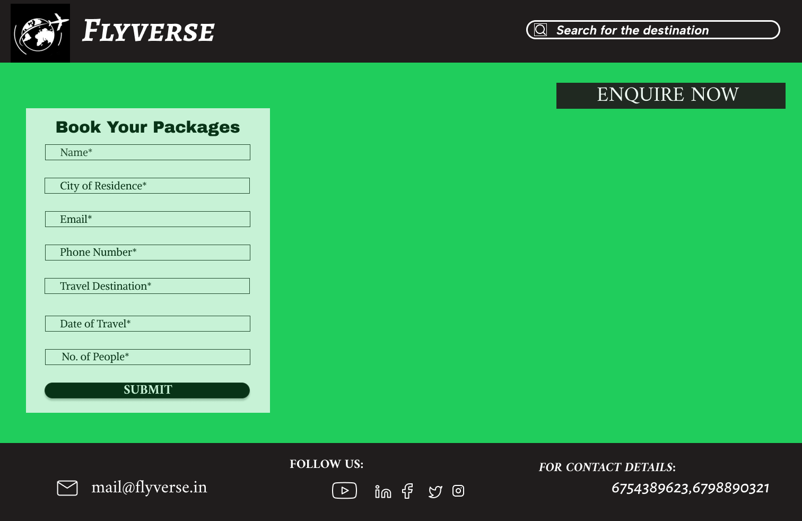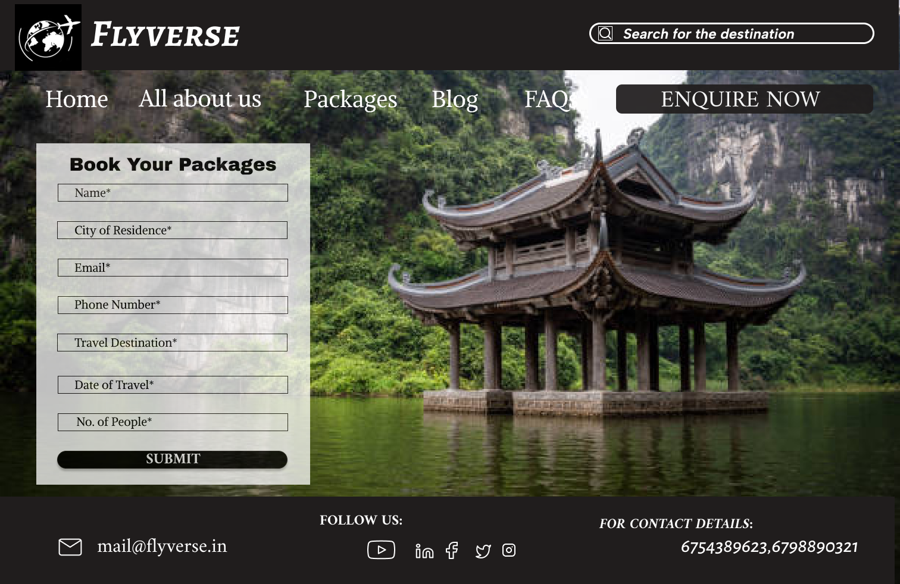
PROTOTYPE LINK:
https://www.figma.com/design/lwoR164DJeMj3qdg7OkMqx/UID-exp-1?node-id=0-1&p=f&t=5LYgLaSvTZuFYnhJ-0

Frame 1 – Weak / Poor Design
This frame demonstrates several UI/UX issues.

Problems Identified
1. No Visual Balance
- The form floats in the middle with excessive empty space around it.
- The page feels incomplete and visually disconnected.
2. Poor Layout Structure
- Elements are not clearly grouped.
- The form and “Enquire Now” button feel unrelated.
3. Excessive Empty Space
- Large unused green areas dominate the screen.
- Creates a dull and unengaging appearance.
4. Weak Visual Appeal
- Plain background with no supporting imagery.
- Lacks depth and professionalism.
5. Poor User Guidance
- No visual cues directing attention.
- Users may feel unsure where to focus.
6. CTA Placement Feels Random
- “Enquire Now” appears isolated.
- Does not feel integrated into the design.

Frames 2 & 3 – Strong / Effective Design
These frames apply better design principles.

Strengths
1. Strong Visual Engagement
- Background travel imagery adds depth and interest.
- Immediately communicates the theme (travel/tourism).
2. Better Layout Composition
- Form is anchored properly on the left.
- Visual weight is distributed more naturally.
3. Clear Section Separation
- Header, content, and footer are visually distinct.
- Improves structure and readability.
4. Improved Aesthetics
- Images + styled panels create a modern look.
- Design feels more premium.
5. Better Use of Space
- No awkward empty areas.
- Content fills the screen effectively.
6. Clearer User Focus
- Form stands out against background.
- CTA buttons are easier to notice.

Key Differences
🔹 Background & Visual Depth
- Frame 1 uses a flat green background → looks empty and basic.
- Frames 2 & 3 use imagery/panels → richer and more engaging.
🔹 Layout Balance
- Frame 1 feels visually unbalanced with too much unused space.
- Frames 2 & 3 distribute elements more harmoniously.
🔹 Professional Appearance
- Frame 1 appears unfinished or prototype-like.
- Frames 2 & 3 look like complete, polished designs.
🔹 User Experience
- Frame 1 may confuse users due to poor composition.
- Frames 2 & 3 guide attention naturally.
🔹 Visual Interest
- Frame 1 lacks excitement.
- Frames 2 & 3 feel dynamic and attractive

